Evaluation of the Homeshare pilots programme
Scoping phase report

12 May 2016

Client | SCIE/Homeshare Partnership
Company | OPM
Title | Evaluation of the Homeshare pilots programme
Subtitle | Scoping phase report
Dates | last published 12/05/2016  last revised 25 Jul. 2017
Status | Draft
Classification | Restricted External
Project Code | 10304
Author(s) | Sophie Reid, Ellie Mendez Sayer, Myles Wilson, Jackie Gallagher, Christine Corlet Walker
Quality Assurance by | Dr Chih Hoong Sin
Main point of contact | Jackie Gallagher
Telephone | 07968 616552
Email | jgallagher@opm.co.uk

If you would like a large text version of this document, please contact us.

OPM
252b Gray’s Inn Road 0845 055 3900
London www.opm.co.uk
WC1X 8XG info@opm.co.uk

Contents
Executive summary 1
1 Introduction 4
1.1 The Homeshare pilots programme evaluation 4
1.1.1 The Homeshare model 4
1.1.2 The HSP partnership 4
1.1.3 HSP Governance 5
1.2 The evaluation approach 5
1.2.1 Aims and objectives of the evaluation 5
1.2.2 Underpinning principles for the evaluation 6
1.2.3 Evaluation design 6
1.3 Scoping with the strategic partners and the pilots 8
1.3.1 Methods used 8
1.3.2 Local contexts 8
1.3.3 Logic modelling 8
1.3.4 Programme level logic model 9
1.3.5 Data collection tool and guidance 9
1.3.6 Secondary data profiling 9
1.4 Report structure 9
2 Thematic analysis of HSP site level scoping 10
2.1 Scoping phase aims and objectives 10
2.1.1 Logic modelling 10
2.1.2 Framework of factors for successful Homeshare schemes 10
2.2 Emerging themes 10
2.2.1 The importance of context 11
2.2.2 Selective targeting 12
2.2.3 Broadening selection 12
2.2.4 Links with existing local agencies and services 13
2.2.5 Local objectives and priorities 13
2.3 Pilot initiation and start-up activities 15
2.3.1 Advertising and marketing 15
2.3.2 Assessment and interview 16
2.3.3 Developing the Quality mark 16
2.3.4 Making successful matches 17
2.3.5 Key elements of the Homeshare agreement 17
2.3.6 Supporting householders and homesharers 18
2.3.7 Other specific delivery activities highlighted by pilot leads 19
2.3.8 Developing local evaluation plans 19
2.3.9 Enablers – what helps development? 20
2.3.10 Barriers – what blocks development? 20
2.4 HSP pilot site outputs 21
2.4.1 Homeshare matches projected 21
2.4.2 Length of matches 21
2.4.3 Fees for householders and homesharers 21
2.5 Common HSP outcomes 22
2.5.1 Summary of HSP site level scoping 24
3 Insights from HSP strategic partners 25
3.1 Impact of the partnership on HSP outcomes 25
3.2 Partner roles and motivations 25
3.2.1 Partnership roles 25
3.2.2 Partner motivations 26
3.3 Commissioning and site selection 27
3.3.1 Criteria for selecting sites 27
3.3.2 What worked well during the commissioning process 27
3.3.3 Challenges during the commissioning process 28
3.4 HSP partnership working 28
3.5 Learning from the start-up work 29
3.5.1 Establishing the pilot sites 29
3.5.2 Wider programme level learning 29
3.6 Priorities for further learning and outcomes 30
3.6.1 Outcomes for the programme 30
3.6.2 Wider outcomes 30
3.6.3 Priorities for further learning from the evaluation 30
3.7 Programme level logic model 32
3.8 Summary of key insights from strategic partners 32
4 Quantitative analysis 34
4.1 Data collection tool development and launch 34
4.1.1 Co-production of the tool 34
4.1.2 Validating and trialling the tool 34
4.2 Area profiling 36
4.2.1 Key data points 36
4.2.2 Data sources 37
4.2.3 Data visualisation 37
4.2.4 Planned use of the secondary data 37
5 Proposals for the next phase of evaluation 38
5.1 Formative changes to primary data collection method 38
5.1.1 Moving from standard timepoints to individual timepoints 38
5.1.2 Planned next steps 38
5.1.3 Key activities and milestones for next phase of work 39
5.2 Managing evaluation risks and challenges 39
5.2.1 Risks and mitigations for the next phase of work 39
5.3 Concluding comments 40
6 List of appendices 41

Executive summary
Introduction
This is the first formative report from the independent evaluation of the two-year Homeshare programme (HSP), which runs from June 2015 to July 2017. The evaluation is commissioned by the HSP strategic partners - Lloyds Bank Foundation, the Big Lottery Fund, Age UK, The Foyer Federation, Shared Lives Plus and the Social Care Institute for Excellence. It summarises the key findings from the initial scoping phase of the evaluation and provides formative learning to help shape and plan the next stages of the evaluation.

The aim of the evaluation is to find out what works best to make Homeshare an economically sustainable business.

This report outlines findings from the scoping phase of the evaluation which has included document review, secondary data analysis and interviews with lead staff at the selected pilot sites and with strategic partners.
Key outputs from the scoping phase of evaluation
The following key outputs are included as appendices to this report:
- Logic models for each of the eight pilot sites;
- Programme level logic model;
- Data collection tool and guidance;
- Area profiling secondary data; and
- A revised timeline to take account of delays in the start-up of the pilots.
Key findings from thematic analysis of site level scoping work
All sites share a set of common outcomes which are summarised and illustrated in an infographic (p.23) and which will enable the HSP to test the core Homeshare model.

There is a wide range of additional local objectives and priorities which will enable the HSP to test a variety of extensions and innovations to the core Homeshare model.

The start-up of the pilots has been affected by delays, including difficulties in recruitment but these have now all been resolved and all pilots are now launched.

Start-up activities such as marketing, matching processes, setting fees, developing the local Homeshare agreement and support arrangements are all now well in hand.

All sites are fully engaged with the HSP evaluation approach and processes and are also developing their own local evaluation plans.

Logic models to support business planning and evaluation have been co-produced and validated with all sites.

Key enablers identified at pilot level are:
- Building on experience by drawing on past learning through Shared Lives Plus and others;
- Good communications which present the Homeshare concept clearly in plain language;
- Segmenting to adopt different advertising and marketing strategies for different audiences;
- Using evidence so that activities and expenditure are informed by knowledge of what works; and
- Being more business-like to streamline and systematise processes.

Barriers identified at pilot level are:
- Anxieties of potential householders and homesharers about possible risks;
- Stereotyping in pre-existing attitudes to younger or older people;
- Homeshare as an unfamiliar concept and the need to attract people to a new idea; and
- Uncertain demand which affects planning for targeting potential participants.
Key insights from scoping work with HSP strategic partners
The lead-in work has taken longer than initially envisaged and has been affected by different internal requirements across the two funding partners.
The timeframe has been further delayed by a variety of issues at pilot level that were either more difficult than anticipated or unforeseen, including problems with staff recruitment and revisions to business plans.
Partnership roles and responsibilities have been clarified and developed and are now bedding down after a busy and challenging lead-in period for the programme.
Working relationships within the partnership are comfortable and open with good collaboration and genuine sharing, openness and honesty.
There is still progress to be made on finding a common language across the different organisations within the partnership group.
Harmonising the monitoring arrangements across the programme has been a priority for the partners and this has now been achieved.
Key enablers for commissioning and selection of pilot sites included:
- Using an open day to attract applicants;
- Working with partners to attract and select applicants;
- Using a broad specification which raised awareness and interest;
- Not specifying funding levels so that applicants had to develop their own financial case.
Key challenges during this phase included:
- The different internal requirements for the publicly funded and independent charity funding partners for whom different accountability requirements apply;
- Low security of tenure offered by the Homeshare model which is a disincentive to housing association tenants currently in short term housing to move on to this option;
- The welfare benefits system which excludes potential homesharers in receipt of housing benefit.
A programme level logic model has been developed which has built on an early draft by Big Lottery, been linked to and informed by the common outcomes generated by pilot site logic models and validated in co-production with the Delivery Group.
Quantitative analysis
A shared data collection tool to monitor the householder and homesharer journey has been developed in co-production with the pilot sites and is in use for the first quarter of monitoring with any further reviews to be made in June 2016.

Secondary data analysis has been undertaken to create a detailed profile of demographic, household and lifestyle data for each area in which the pilots are operating and which will be used in later stages of the evaluation to contextualise analysis of the participant data.
Proposals for the next phase of the evaluation
Key activities and milestones for the next phase of the evaluation through to November 2016 are set out in the final section of the report together with an assessment of evaluation risks and planned mitigating activities.
Concluding comments
Despite some unforeseen delays and difficulties in the early start-up phase of the HSP it has remained on track to meet its aims and objectives.

We have taken account of the formative learning from the scoping stage to adjust the detailed evaluation design, methodology and timeline so that the evaluation is still able to deliver on its key formative and summative evaluation reporting milestones.

Introduction

This chapter introduces the Homeshare programme, the main partners and the evaluation. We explain the purpose of the report, the aims of the evaluation and the principles which underpin our approach.

The Homeshare pilots programme evaluation
This is the first report from the evaluation of the Homeshare programme (HSP). It summarises the key findings from the initial scoping phase of the evaluation and provides formative learning to help shape and plan the next stages of the evaluation.

The Homeshare model
As a general model, Homeshare is an initiative which brings together older people and others who need support to stay in their homes (known as householders), with young people and others (known as homesharers), who provide companionship and low level practical support in return for an affordable place to live.
Lloyds Bank Foundation and the Big Lottery Fund have together invested £2m in the HSP to support eight pilot Homeshare schemes in England and Scotland. The programme seeks to demonstrate that Homeshare can be an effective, achievable and economical way of meeting housing and support needs and to test and evaluate whether the model is a sustainable and effective response to the challenges of high housing costs and an ageing population which can be rolled out on a wider scale across more communities in the UK. The HSP was initiated in June 2015 to run for two years up to July 2017.

The HSP partnership
Led by Lloyds Bank Foundation (LBF) and the Big Lottery Fund the HSP involves a range of partners which includes:
- Age UK managing the HSP work plan, including risk register, and monitoring arrangements; providing direct support to sites and working with householders to provide a channel for older people’s voices and experiences;
- The Foyer Federation drawing on extensive experience of housing and support for young people in transition to independence, working with homesharers to provide a channel for their voices and experiences;
- Shared Lives Plus providing guidance and practical best practice support from the wider Homeshare sector;
- Social Care Institute for Excellence (SCIE) leading, commissioning and quality assuring the independent evaluation of the programme and providing social care sector and policy knowledge and expertise.
The national support offer from the partnership also includes a financial modelling tool, business mentoring, and marketing support provided through LBF, and will include a dedicated website and information sharing ‘hub’ to be delivered and managed by Shared Lives Plus, and which is currently under development.

HSP Governance
The HSP has put in place a governance and reporting structure including a Programme Partnership Board, chaired by LBF, responsible for strategic decision making for the programme and a Programme Delivery Group, chaired by Age UK, which considers operational delivery, co-ordinates contact and activity between schemes and partners, escalates emerging key issues to the Board and co-ordinates the activities of other working groups such as the Communications Group which manages external communications and events.

The evaluation approach
The evaluation is formative and seeks to capture learning throughout the implementation of the HSP to help shape and improve its design and support the performance of the pilot schemes involved.

Aims and objectives of the evaluation
- The overall aim is to find out what works best to make Homeshare an economically sustainable business to engage in. The objectives of the evaluation are therefore to:
- Find out what works to successfully develop and deliver a quality-assured Homeshare scheme;
- Find out what works best when planning, providing and further developing a Homeshare scheme and determine what good practice can be transferred;
- Find out what may work to encourage a wider out-of-London adoption of Homeshare;
- Demonstrate what, if any, economic benefit Homeshare provides, from public, private and social value perspectives;
- Develop a framework of factors that can be used in the future to determine the strength and likely effectiveness of bids/proposals for Homeshare schemes; and
- Share the learning during and as a result of evaluation to describe best practice in developing economically sustainable Homeshare schemes.

Underpinning principles for the evaluation
The evaluation approach is one of dynamic improvement, aiming to make the most of the learning from every stage of the programme to support the pilot schemes in their development. This approach includes the following principles:
- Involvement and engagement of the evaluators as key contributors to ongoing processes for learning and development.
- Support for local monitoring and self-evaluation which supports sustainability, engagement and develops local ownership.
- In co-production with the sites themselves, identifying, accounting for and explaining the links between context (policies and demographics), strategies, processes, inputs, outputs and any impacts and outcomes.
- Minimising burdens and duplications for the pilot sites.
- Maximising use of existing secondary data sources so that primary data collection is targeted to collect only information that cannot be obtained from other existing sources.
It should be noted that the initiation phase for the pilots has taken longer than initially envisaged which has meant that a number of the pilots only went ‘live’ in early 2016 rather than in the latter half of 2015 as originally planned. The evaluation timeline has therefore been adjusted to take account of this whilst still working to the same final reporting milestone of July 2017.

Evaluation design
The overall process evaluation design for the HSP seeks to identify, explore and explain impact and outcomes (for all participants and at all levels) and to account for change over time.
The evaluation takes a mixed-methods approach using both quantitative and qualitative data for the pilot sites which includes:
- Secondary analysis of published quantitative national and local data sets as an important element of site profiling to provide baseline contextual information for each scheme;
- Core common monitoring and evaluation data across all sites;
- Primary qualitative research with pilot site staff, householders, homesharers and local stakeholders to explore evaluation lines of enquiry where information cannot be obtained from other sources, or to provide greater depth and richness of information.
The original design included four interlinked stages, illustrated overleaf.

We have now adjusted this design in co-production with the Delivery Group to take account of the later start-up for the majority of sites which has effectively compressed the timeframe for gathering primary qualitative data on the experiences of householders and homesharers. There have therefore been two main changes to the design:
- Baseline primary data collection: Apart from Novus, completed matches and new Homeshare starts across the sites are now not expected to begin until summer/early autumn 2016. The evaluation design includes two waves of primary data collection drawn from site visits, the first wave to provide a baseline data set and the second wave to provide “endline” data to help explore and understand a range of different householder and homesharer journeys. This requires face to face interviews and group discussions with householders and homesharers, so baseline data cannot be collected from sites until they have each made a number of matches. The original plan was to collect baseline data across all the sites at the same timepoint. However, following discussions with the HSP Delivery Group we are now flexing this approach to undertake the baseline primary research between July and early October 2016 to take account of the different timelines and milestones for each site. The second wave of endline primary research will then be undertaken in April and May 2017.
- Feasibility of a comparative study: A key element of the scoping work is to explore and identify options for an additional comparative evaluation; ascertain whether further comparative study with other non-HSP Homeshare schemes would be practicable and useful and to advise the Partnership on the feasibility and likely costs of such a study. The original aim was to focus comparative work on the two initial HSP sites funded by Lloyds Bank Foundation. However, revisions to the original application to change the delivery model for the Age UK Oxfordshire (agreed in mid-April 2016) have also delayed the start-up for this scheme which is now launching in early May 2016. Now that all schemes are effectively up and running, the feasibility work should be completed by the end of May 2016, drawing on the site profiling completed during this scoping phase.
We have therefore adjusted the four interlinked evaluation stages to allow for these design changes. A separate paper assessing the feasibility of and options for a comparative study will be submitted at the end of May 2016, and an interim report including baseline data from the primary research with sites will be submitted at the end of November 2016, with the final summative report including primary research endline data in July 2017. These revisions are illustrated overleaf.

Scoping with the strategic partners and the pilots

Methods used
Our scoping work included a document review covering the background to the development of the HSP and a structured interview with representatives from each of the strategic partners. We also undertook scoping telephone interviews with site leads from all eight pilot sites. This included early initiation calls, eight primary structured interviews, and further fact checking calls to support the co-production of logic models and a data collection tool and guidance. We reviewed the core documents for each pilot including programme applications, financial information such as budgets and predictive information from applying the LBF financial modelling tool, marketing materials and any other early documents available. We also reviewed published data available for secondary analysis, including demographic, household and life style data. This scoping work produced:
- Insight into the development of the strategic partnership;
- Local contextual information for each pilot site;
- Logic models for each pilot site;
- A programme level logic model;
- An evaluation data collection tool and guidance for use;
- Area secondary data profiles for each site.

Local contexts
In the structured interviews with pilot leads we explored the context for each site; their intended impacts and outcomes; the resources and inputs they will have; activities they will undertake and outputs they plan to produce.

Logic modelling
The qualitative data from the interviews was then thematically analysed alongside the pilot sites’ initial application forms and completed financial/budget information (including the financial modelling tool produced by LBF), to draft a logic model. A logic model is a visual analysis tool which describes how planned inputs, activities and outputs will achieve the desired outcomes in a project. Researchers remained in contact with site leads to clarify any points and fully complete the logic models for each pilot site. The eight pilot logic models are provided in Appendix A. The draft models were validated with the sites during an evaluation workshop as part of the Learn and Share Event hosted by Age UK in February 2016. These are ‘live’ documents which are likely to change through the lifespan of the pilots and which can be used by the pilot sites themselves to understand and articulate how they plan to achieve their desired outcomes.

Programme level logic model
The individual site logic models, along with background documents produced by the HSP and an early draft programme logic model developed by the Big Lottery were then used to draft a programme level logic model which summarises how the HSP inputs, activities and outputs will contribute to the desired programme level outcomes. The programme level logic model was tested and revised as a co-production activity with the Delivery Group in April 2016 and is included as Appendix B.

Data collection tool and guidance
Simultaneously, Aleron (our specialist quantitative analytics partner) undertook scoping conversations with pilot site leads in order to identify and agree the feasibility and relevance of key common data points to be collected by all pilots on individual householder and homesharer journeys (such as their interactions with the pilot, the length of matches etc). These conversations, including a discussion session with pilot site leads at the HSP Learn and Share Event in February 2016, were used to develop a standardised Excel-based common data collection tool to be used by all the pilot sites (the data collection tool and guidance is included in Appendix C).

Secondary data profiling
Aleron also completed secondary data analysis in order to create detailed profiles for the areas in which each of the Homeshare pilot sites are operating, including demographics, household data and lifestyle data (area profiles are included in Appendix D).

Report structure
The following sections of this report summarise the findings from the initial scoping phase for the evaluation and provide:
- Section 2: Scoping at HSP site level - a thematic analysis of the scoping work with the pilot sites and secondary data analysis;
- Section 3: Insights from partner interviews – a thematic analysis of the scoping interviews undertaken with the strategic partners;
- Section 4: Quantitative analysis - a description of the data profiling and data collection undertaken and planned; and
- Section 5: Proposals for the next stages of the evaluation - including an update on risks and challenges and a revised timeline.

Thematic analysis of HSP site level scoping

In this chapter we summarise the key findings from our scoping interviews with pilot site leads and review of secondary data from pilot sites, including initial application forms and financial information.

Scoping phase aims and objectives
The aims and objectives of the scoping phase with pilot sites were to:
- Introduce ourselves as the evaluators and co-create a common understanding of the benefits of the national programme evaluation with the various stakeholders;
- Capture local intelligence about any pre-existing and/or complementary activity, learn more about the local context;
- Discuss the planned implementation of the pilot, funding sources, activities to date and details of pilot delivery plans in order to inform baselining;
- Discuss any local evaluation activities that the sites are already planning, including the reporting requirements they may have to any local commissioners;
- Identify next steps for the evaluation, including timescales for conducting fieldwork.

Logic modelling
Logic models have been co-produced through telephone interviews, review of documents and fact-checking discussions with site leads, validated through further discussion at the evaluation workshop in February 2016 and are provided as Appendix A. The individual pilot logic models are crucial building blocks for the evaluation overall, as they are intended to map as comprehensively as possible all the inputs, activities and outputs for each Homeshare scheme, and will help to build a detailed understanding of both the barriers to and enablers of a successful scheme.

Framework of factors for successful Homeshare schemes
From the logic models we will be able to build one of the key outputs from the evaluation – the framework of factors to be used to determine the strength and likely effectiveness of future Homeshare proposals. The inputs identified in the logic models will also support the economic assessment strand of the evaluation.

Emerging themes
We have synthesised key findings from our scoping interviews with pilot site leads and secondary data from pilot sites, including initial application forms and financial information in the following thematic summaries which are presented to reflect the general sections in the logic models: context, activities, outputs and outcomes.
The figure overleaf provides a visual summary of the local contexts for each pilot scheme.

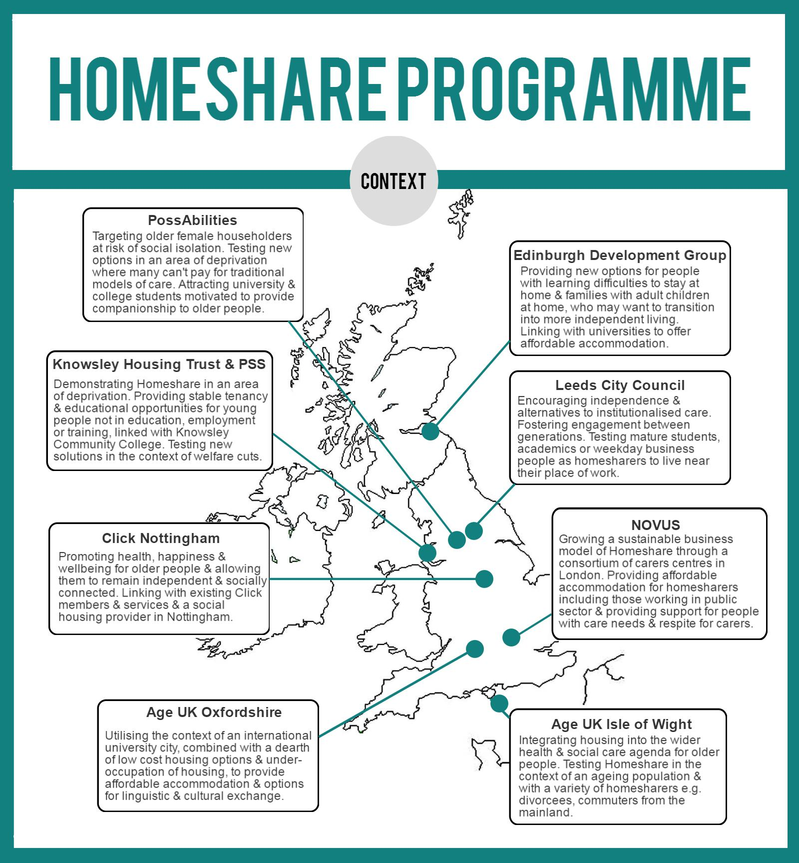
Visual summary of the pilots across the programme, including location, main beneficiaries and main aims

The importance of context
The varying local contexts in which pilot sites are operating result in important differences in their operating models and the specific sub-populations they aim to target. However, all share some common issues which they hope to tackle:
- An ageing population and greater number of older people living alone, at risk of social isolation and loneliness;
- Shrinking public resources; and
- An increasing shortage of affordable quality housing options.
Key contextual differences between the sites’ operating models are summarised below, including audience and fit with existing services. Where these decisions have been made according to the local context such as local need, demographics or geographical features, this is stated.

Selective targeting
Some schemes have decided to focus on specific demographics and narrowed their target audience, for example:
- PossAbilities (Rochdale) focus on older women, as a result of research which found a large population of older women living alone;
- Edinburgh Development Group focus on people with learning disabilities, whether as householder or homesharer; and
- Age UK Oxfordshire (along with many of the other schemes) focus on attracting university students as homesharers. This is influenced by the local context of Oxford as an international university city labelled as the UK’s least affordable city in the 2016 Lloyds Bank Affordable Cities Review.

Broadening selection
Other schemes have taken the decision to widen the pool of potential householders and homesharers, including:
- Age UK Isle of Wight will experiment with over 50s divorcees or international healthcare workers as homesharers. This is influenced by the local context of the Isle of Wight as an island with an ageing population (a retirement destination), no student population and a higher than average divorce rate amongst the over 50s.
- Leeds City Council and Age UK Isle of Wight are testing weekday workers (who work away from home during the week and return at the weekends) as homesharers, due to the local contexts of large commuter populations.
- Knowsley Housing Trust and Person Shaped Support (PSS) are working with young people who are not in education, employment or training as homesharers, due to the local context of a larger than average NEET population.

Links with existing local agencies and services
All of the schemes are run by organisations that can bring particular expertise or contacts to the project, offering opportunities for Homeshare to be aligned with other services they offer. These include:
- Housing associations or links to housing associations for example, Knowsley Housing Trust, Click Nottingham and Leeds City Council, which enables access to a pre-existing pool of potential householders or homesharers as well as an expert understanding of the welfare system and any implications for Homeshare arrangements.
- Older people’s groups for example, Age UK Oxfordshire and Age UK Isle of Wight who are familiar with the needs and expectations of older people, are able to contact and make referrals through existing databases and can also refer to other internal services such as Handyperson services or social groups.
- Educational opportunities or links to educational institutions for example, Knowsley Housing Trust & PSS link with Knowsley Community College; Age UK Oxfordshire and Leeds City Council link with local universities and are able to offer homesharers additional benefits of education and training opportunities, or provide access to potential homesharers from universities and colleges for example, social care students.
- Carers groups or respite links for example, Novus as a consortium of carers’ centre is able to tap into a pre-existing pool of potential householders through carers who may welcome the extra support a homesharer could offer.
- Links to local community and voluntary services for example, Age UK Isle of Wight, Edinburgh Development Group, Click Nottingham are able to access potential householders or homesharers and hold practical information about the needs and expectations of specific demographic groups such as people with learning disabilities. These links facilitate referral pathways between the Homeshare scheme and voluntary organisations, services and activities.
- Links to commissioners for example, Leeds City Council, Age UK Oxfordshire and Knowsley Housing Trust & PSS are able to refer from and between Homeshare schemes and locally commissioned health and social care services. This also facilitates the potential for onward funding to ensure the longer term financial sustainability of schemes.
- Links to or experience of Shared Lives schemes for example, PossAbilities, Leeds City Council, Knowsley Housing Trust & PSS where much of the infrastructure needed for matching and practical knowledge of supporting matches is already developed and may be suitable for adaptation for Homeshare.
It should be noted that these examples have been drawn from scoping interviews with pilot site leads simply to illustrate the range of links and their benefits, and so are not a comparison of the extent to which links apply to the different sites.

Local objectives and priorities
All pilot sites aim to achieve specific long-term impacts in line with local objectives and priorities. More work will be needed during the next formative phase of the evaluation to relate these desired impacts to potential longer-term outcomes for householders and homesharers so that these aspirations can be tested. They are summarised in the following table.

Pilot site | Local objectives and priorities
Age UK Isle of Wight | Putting housing at the centre of wider housing and social care agenda. Age UK IoW sees housing as a root cause of problems in later life – if housing is not physically adapted, or older people are asset-rich but cash-poor. They want to demonstrate that the right home environment and informal support can have impacts such as delaying the need for formal social and personal care.
Age UK Oxfordshire | Fostering intergenerational understanding and combating social isolation in the context of an international university city with a rapidly ageing population and high housing costs, Age UK Oxfordshire wants to provide companionship and support for older people living alone and provide new solutions to the shortage of affordable housing in the city.
Click Nottingham | Promoting health, happiness and wellbeing and allowing older people to live independently and make a social contribution. Click Nottingham want to encourage older people to stay active and remain involved in their communities through social groups and volunteering.
Edinburgh Development Group | Providing opportunities for supported independence for people with learning disabilities, offering individuals with learning disabilities who live with their carers the chance to explore living independently by sharing their home with a homesharer or becoming a temporary homesharer themselves. This also gives carers the chance to explore their own interests outside of the caring role.
Knowsley Housing Trust & PSS | Demonstrating that Homeshare can work in an area of multiple deprivation. KHT & PSS work in an area where the percentage of working age population accessing DWP benefits is double the national average. They are keen to demonstrate that Homeshare can provide mutual benefits to vulnerable householders and homesharers, especially in a context of welfare reform from April 2016. They also hope to reduce the NEET population (not in employment, education or training) by partnering with Knowsley Community College and change perceptions of young people in the community.
Leeds City Council | Enabling older people to age in their place of choice and becoming ‘The Best City in the UK to Grow Old’. Leeds CC has identified living alone as a key factor in loneliness and social isolation amongst older people, and a key risk factor for physical and mental health deterioration. They hope to develop capacity within the community to reduce isolation and loneliness, support older people to age in their place of choice and provide affordable housing options for younger people.
Novus | Developing a strong and sustainable market for Homeshare across London and supporting unpaid carers. Novus is a consortium of carers’ centres and has identified the potential for Homesharers to provide support and respite opportunities for full-time carers. They are keen to establish a sustainable business model for the scheme, creating a funding stream which is fed back into the carers’ centres to provide support for unpaid carers.
PossAbilities | Supporting older people (particularly women) at risk of social isolation and loneliness. PossAbilities has identified three wards with high numbers of older female householders/occupiers living alone. They are keen to support these older people in their own homes for longer and provide companionship, while offering low cost accommodation for students and low paid workers who can’t afford accommodation within Manchester.

This information has been drawn from pilot sites’ application forms and further clarified with site leads in scoping interviews.
It will be important during the next stage of the evaluation to explore further how these local priorities have influenced the design of the pilots’ operating models and to clarify the outcomes anticipated at local level, in order to evaluate what is achieved by the evaluation endline.

Pilot initiation and start-up activities
In this section we discuss the variety of activities that the pilots have been undertaking and planning in order to launch their scheme and prepare for the immediate and longer term delivery phases of their work. Generally these activities are common to all pilots unless otherwise stated. They include:
- Advertising and marketing;
- Managing enquiries;
- Assessment and interview;
- Matching process;
- The Homeshare agreement;
- Ongoing client support and engagement; and
- Local evaluation plans.
We also highlight some of the early examples of enablers and barriers that the pilots have experienced so far in their start-up phase.

Advertising and marketing
The pilots have applied a range of advertising and marketing activities to promote their schemes, summarised below.

Pilot site | Advertising and marketing strategy
Age UK Isle of Wight | Initially raise awareness and then target specific groups, drawing on past experience of engaging with older people. They currently have a quarterly forum with Isle Engage (a local marketing agency) to shape their Ageing Better programme. They will use this forum to market Homeshare and aim to receive feedback and information from the variety of steering groups they participate in.
Click Nottingham | Much of the advertising and marketing has been done via word of mouth, but also through marketing and communications companies. They plan to develop a referral system for Homeshare and to target homeowners in certain areas. They will also be reviewing the most effective forms of marketing, for example using leaflets, posters, advertising companies, and will consider developing a website to advertise to a younger audience.
Edinburgh Development Group | The strategy will involve advertising through university societies, such as those for social work. They will advertise Homeshare to young people as housing that is both affordable and a chance to create relationships and connections. They have put out general adverts to raise awareness and will then follow this up with focus groups to gauge interest, explain more about Homeshare, and explore alternative ideas for how it might work.
Knowsley Housing Trust & PSS | The plan is to first engage with potential users to identify the best means for advertising and marketing. This engagement will involve insight workshops with the target groups and professional stakeholders such as the older people’s support team at the council.
Leeds City Council | The plan is to utilise the advertising communications team at Leeds City Council. The senior communications manager is on the project partnership board for Homeshare.
Novus | Has advertised in free editorials in magazines and newspapers and ran a social media campaign. They have a subscription to a flat-share service and have advertised on the Gumtree website for homesharers. They also held talks and ran workshops at the Chartered Institute of Housing conference in Strafford.
PossAbilities | The Homeshare Advisory Group and existing network of supporting agencies will be the primary channels for distributing information. They will use psychographic segmentation techniques to profile the target groups in order to understand their lives, interests, motivations and barriers and what factors they are most responsive to and influenced by. Marketing and advertising will be long-term and they hope to facilitate this once matches have been established who can provide human interest stories and become advocates for the scheme.

Assessment and interview
Broadly the same approach is common across the schemes. All applicants who express an interest in the programme are screened to judge their understanding and expectations of the programme and to safeguard the other party in the prospective match. Application forms for homesharers cover basic information including interests, health, lifestyle, occupation, working hours, longer term plans and areas where the prospective sharer can offer support, such as cooking, housework, gardening, shopping, laundry, pet care and DIY. Application forms for householders include information on support required, health, intensity of need, the accommodation and its location, interests, preferences and length of need.
Interviews provide an opportunity for the organisations to explain the programme in more detail and to assess applicants’ suitability for the programme, what they can gain from it, and what they can contribute.

Developing the Quality mark
Developing a robust and respected standard may well be key to the future sustainability and scalability of the Homeshare model. One of the primary outputs of the HSP will therefore be the development of a Quality standard or “kitemark” for Homeshare to be led by Shared Lives Plus. The screening, assessment and interview processes now being established will be key elements of these Quality protocols. All schemes will be responsible for safeguarding householders and homesharers and ensuring their wellbeing and safety by minimising risk. Every scheme must manage risk for both householders and homesharers and address this effectively, helping participants to understand both the risks and the potential benefits and to make informed choices as a result. All schemes will undertake Disclosure and Barring Service (DBS) checks, request references and undertake basic financial checks as part of satisfying this responsibility. Assessments of householder applicants will include risk assessments of the home, the location of the property (in particular in relation to public transport), and health issues and support needs of the householder. In cases where applicants are not suitable for Homeshare they may be put in touch with other services.
Some pilots reported that their assessment processes will be more intensive for homesharers. For example, PossAbilities will assess homesharer applicants for their competence against set criteria and where weaknesses are identified they will be offered training to ensure they fulfil the criteria. Only when they fulfil the criteria will they be interviewed.

Making successful matches
It is too early to comment on how well the matching process is working across the programme as only Novus has matches in place to date. The data collection tool (Appendix C to this report) will enable a common approach to analysing the householder and homesharer journeys and the progress of matches once matches are underway.
The matching process initially involves considering personalities, interests, location needs, etc., and some organisations, such as Click Nottingham, already have experience from other work. During the next phase of the evaluation we will explore with pilots the scope for using software for matching as volume increases, as well as manual evaluation of applications. The elements of matching can include:
- Using application forms and individual interview information to identify potential compatibility;
- Introductory meetings; and
- Use of trial periods.
Once prospective matches are made, informal face-to-face introductions take place which allow people to socialise and see how they get on, and also offer an initial opportunity to discuss ground rules and agreements for living together. In Harrow the householder is introduced to two or three potential homesharers so as to find the most appropriate match before making a decision.
A number of pilot leads emphasised that the introductory meeting is on neutral ground and in all cases the meetings are facilitated by one or more professionals.
Some pilots plan a trial period, for example in Harrow if both the householder and homesharer are happy to go ahead with the match then they undergo a one-month trial period with daily contact with Novus to raise issues or disagreements. Age UK Isle of Wight plan to engage with householders whilst waiting for a match to be made in order to build trust and establish a good relationship. For example, they will undertake holistic assessments of the householder and their house and refer to other services as needed, such as handrail installation or other adaptations.

Key elements of the Homeshare agreement
A number of pilots have drawn on the model agreement from Shared Lives Plus to inform the detail and policies in their Homeshare agreement. Schemes will also need to satisfy themselves that they are compliant with current legal and financial regulations within their local model of Homeshare. Age UK Isle of Wight has also sought advice and guidance from Citizens Advice Bureau, particularly with regard to council tax.
Key elements of the model agreement include:
- A statement of the aims of the match and the general terms and conditions;
- The role of the Homeshare scheme in providing support;
- Length of agreement and what happens when the arrangement ends;
- A statement about shared space in the home and respect for privacy;
- Furniture provided by the householder or brought by the homesharer;
- An agreement on normal hours of work/study/leisure and anticipated absences from the home;
- Arrangements for shopping, cooking and sharing and the use of the telephone, television, computer etc;
- How use of utilities will be assessed and bills shared;
- Any issues to do with pets, smoking, use of alcohol, car parking, visitors and overnight guests.
These headline areas permit flexibility within individual Homeshare agreements which can be tailored to the individual matches and people involved. For example, Age UK Isle of Wight plans to facilitate a session with the homesharer and householder to discuss the agreement and what should be included. To facilitate this, they also plan to produce a document with FAQs to send out to those who express an interest, so that any issues are addressed quickly.

Supporting householders and homesharers
A variety of ongoing support and engagement activities will take place throughout, including:
- Regular check-ups with homeowners / homesharers: Click Nottingham will schedule visits after six weeks. The development worker in Knowsley will contact householders and homesharers monthly, similar to Shared Lives. Age UK Isle of Wight will make regular telephone calls once a week for the first five to six weeks, but only if needed. PossAbilities will monitor matches through twelve weekly monitoring visits and Annual Reviews.
- Individual support: Age UK Isle of Wight has two support workers, one to support the householder and the other to support the homesharer, so that views are represented separately. If there are disputes, each party will then have their own advocate. PossAbilities offers regular support for both parties separately to ensure they get support independently of one another.
- Training: homesharers in Edinburgh will receive mandatory training on disability. Leeds City Council has a training budget but the content is not yet decided. PossAbilities plans to run group training, as opposed to one-to-one, once every two months but may initially run one-to-one training if too difficult to organise group training.
- Interaction with other homesharers/householders: Knowsley Housing Trust hopes to provide opportunities for homesharers to get together with other homesharers every 6-8 weeks. Those signed up in Nottingham will become members and have access to Click Nottingham social events so that they can develop their own support systems. Leeds City Council will set up forums for homesharers and homeowners.
- Practical support: Age UK Isle of Wight will help homesharers with moving in.
- Emergency support: If the Homeshare starts breaking down, for example if the older person’s health deteriorates, then Age UK Isle of Wight plans to provide ongoing support such as bereavement support. They will also support the homesharer in sudden need of accommodation.
- Homeshare guidance: PossAbilities will work alongside Shared Lives to develop and implement Homeshare guidance/policies and procedures and to develop handbooks for both the homesharer and householder.

Other specific delivery activities highlighted by pilot leads

- Addressing the legalities around tenancies before the matching process, for example, queries on council tax and impact on benefits.
“Legalities around tenancy, different benefits setups, engaging with the person to make sure there are no impacts on their benefits situation / council tax. We want to sort these up front before starting the matching process because it might be a complicated and unique situation for each person. We will address FAQs in the assessment and interview stage.” (Knowsley)
- Documenting and looking at reasons for people applying for Homeshare. For example, what other opportunities there would be if they hadn’t approached Homeshare.
“Proving the business case – we would want to document and look at reasons for people coming to Homeshare. If they didn’t approach Homeshare then what other opportunities would there be? We would want to do that at the assessment stage.” (Knowsley)
- Novus plans to introduce incentives, such as free magazine subscriptions, to homesharers and householders for getting together for socials, in order to enhance communication and add value to the programme.

Developing local evaluation plans
All sites have engaged well with the evaluation/evidence agenda and are keen to build a strong evidence base for their scheme. In particular the pilots have welcomed the use of a common data collection tool to track the individual householder and homesharer journey across all sites and have all contributed actively to its development. In addition to the programme evaluation, pilot sites are also planning a variety of other self-evaluation activities. All except Leeds City Council are planning internal evaluation whereas Leeds City Council has commissioned Leeds Beckett University to undertake an evaluation using both qualitative and quantitative methods. Pilots’ self-evaluation methods include a mix of quantitative and qualitative approaches. For example, Click Nottingham administers a quantitative questionnaire when people are accepted onto the scheme and again after four months, eight months and one year, which measures a set of indicators on a scale of 1 to 10 and assesses wellbeing, anxiety, depression, and use of services. The Novus questionnaire however is qualitative, and contains open-ended questions to explore expectations, relationships, what participants enjoy most, etc.
Other organisations evaluate through face-to-face discussions. For example, Edinburgh Development Group undertakes a six- weekly review and also runs a community circle to help homesharers/ householders connect with each other and evaluate what works well and not so well. Knowsley Housing Trust plan to run service design focus groups as well as collect information through an Impact Reporting Toolkit.

Enablers – what helps development?
Although most pilots are still in their start-up phase they are already able to identify some of the key enabling factors that have helped with their early work. These include:
- Building on experience: drawing on past learning from Shared Lives Plus.
“Past learning from Shared Lives [and] the learning we have from all that we run. We have no reason to believe it won’t work for Homeshare.” (PossAbilities)
“A lot of the details and policies will be drawn from online resources from Shared Lives Plus and then tailored to this project.” (Leeds)
- Communicating: presenting Homeshare clearly through the use of plain language.
“What’s worked well is simplifying the message of what Homeshare will be; not making it complicated, simplifying the language, getting the message right is important and worked well for Shared Lives.” (PossAbilities)
- Segmenting: adopting separate advertising and marketing strategies for different audiences.
“We’re dealing with two completely different groups and different in how they receive and take in information, so have to have completely different marketing strategies for both groups - church tea party vs radio call out.” (PossAbilities)
- Using evidence: ensuring the advertising and marketing is informed by what works well, so as to make sure spending is based on evidence.
“We would like to get more response to our advertising and marketing so we need to look at the quality of what we are producing to make sure we are measuring what works so we make spending decisions on evidence- understanding - why are we choosing this ad in this time and what do we get back out of it?” (Novus)
- Being more business-like: to streamline and systematise processes.
"One of the things that have made a difference is setting up a Direct Debit scheme for the payments, other than receiving cheques or cash." (Novus)

Barriers – what blocks development?
Pilots have also experienced some obstacles which have needed to be tackled as part of their early work. These include:
- Fear: Potential participants’ anxieties about the risks.
“It’s the risks of Homeshare that are the first things to spring to mind, so we’d want to do a marketing campaign that interests and attracts people to the idea.” (Isle of Wight)
- Stereotyping: Householders/older people’s pre-existing attitudes towards young people.
“There’s that inherent prejudice about young people that you’re putting a young person in with an older person and it’s like ‘oh that poor old person’. So I think there was quite a lot we had to leap over in terms of attitudes about young people.” (Knowsley)
- A new concept: Needing to generate awareness, understanding and interest, and attracting people to a new idea.
“[Our] biggest concern [is to] introduce it in such a way that it interests people…we’d want to do a marketing campaign that interests and attracts people to the idea.” (Isle of Wight)
- Uncertain demand: Knowing who to target for Homeshare, for example whether to target all older people or only those older people needing more help such as those with dementia, MS, learning disabilities, etc.
“The market is huge but there are so many different segments, [and] it’s knowing where to go on both sides. Traditionally we target older people. Traditionally people with dementia are costly to support. We need some less needy people e.g. single mothers might benefit from having someone living in to sort the kids out, people with MS or learning disabilities, Local authorities if people don’t meet eligibility for council support.” (Novus)

HSP pilot site outputs

Homeshare matches projected
Leeds City Council expects 25 successful matches to be made and maintained. PossAbilities aim to achieve 114 matches (228 people to benefit) over five years, but the interviewee reiterated that they will focus on quality and not quantity. Click Nottingham aims to achieve five matches by Year 1, up to 20 for Year 2, 40 for Year 3, and up to 60 for Year 4.

Length of matches
PossAbilities are aiming for three types of matches:
- Short term - up to eight weeks to assist with discharge of householder from hospital;
- Medium term - around ten months to cover an academic year of a student homesharer; and
- Long term - ongoing after a one month trial.
Click Nottingham has not set a target for the length of matches. On the other hand, Leeds City Council will ask for people to commit for six months but ideally aims for an average match to last one year. Similarly, Novus expects successful matches to last for a minimum of six months with some lasting a year, however they expect some to naturally come to an end in six months if they don’t appear to be working.

Fees for householders and homesharers
The interviews identified differences in fees between the pilot sites. Some organisations, such as Edinburgh Development Group, charge the same fees for both the homesharer and homeowner. In Edinburgh the fees will increase year-on-year once the programme becomes more established. In other sites the fees are greater for the homesharer. The greatest difference is in Leeds where householders are charged £50 a month and homesharers are changed £200, however this will be tested as the programme develops. Novus will be flexible with the fees according to individual situations, for example if a homesharer is matched with a householder who has high needs and now needs more practical support. They will all consider offering discounted rates for homesharers if they are matched with somebody who lives in an inaccessible area.
PossAbilities will additionally charge a one-off registration fee of £25 for the homeowner to cover the costs of the selection and matching process and general admin. Their rationale behind this is to establish a commitment from the homeowner and compensation if they withdraw. Utility charges and a contribution towards food will also be documented in the Homeshare agreement and negotiated on a case-by-case basis. PossAbilities will use guidance from Homeshare UK to set these fees.

Common HSP outcomes
From our scoping work with the pilot sites and the development of individual logic models we have been able to build a picture of the desired outcomes which are common to all schemes and which link to and support the overarching programme level logic model. The following figure provides an illustrative summary of these common envisaged outcomes.

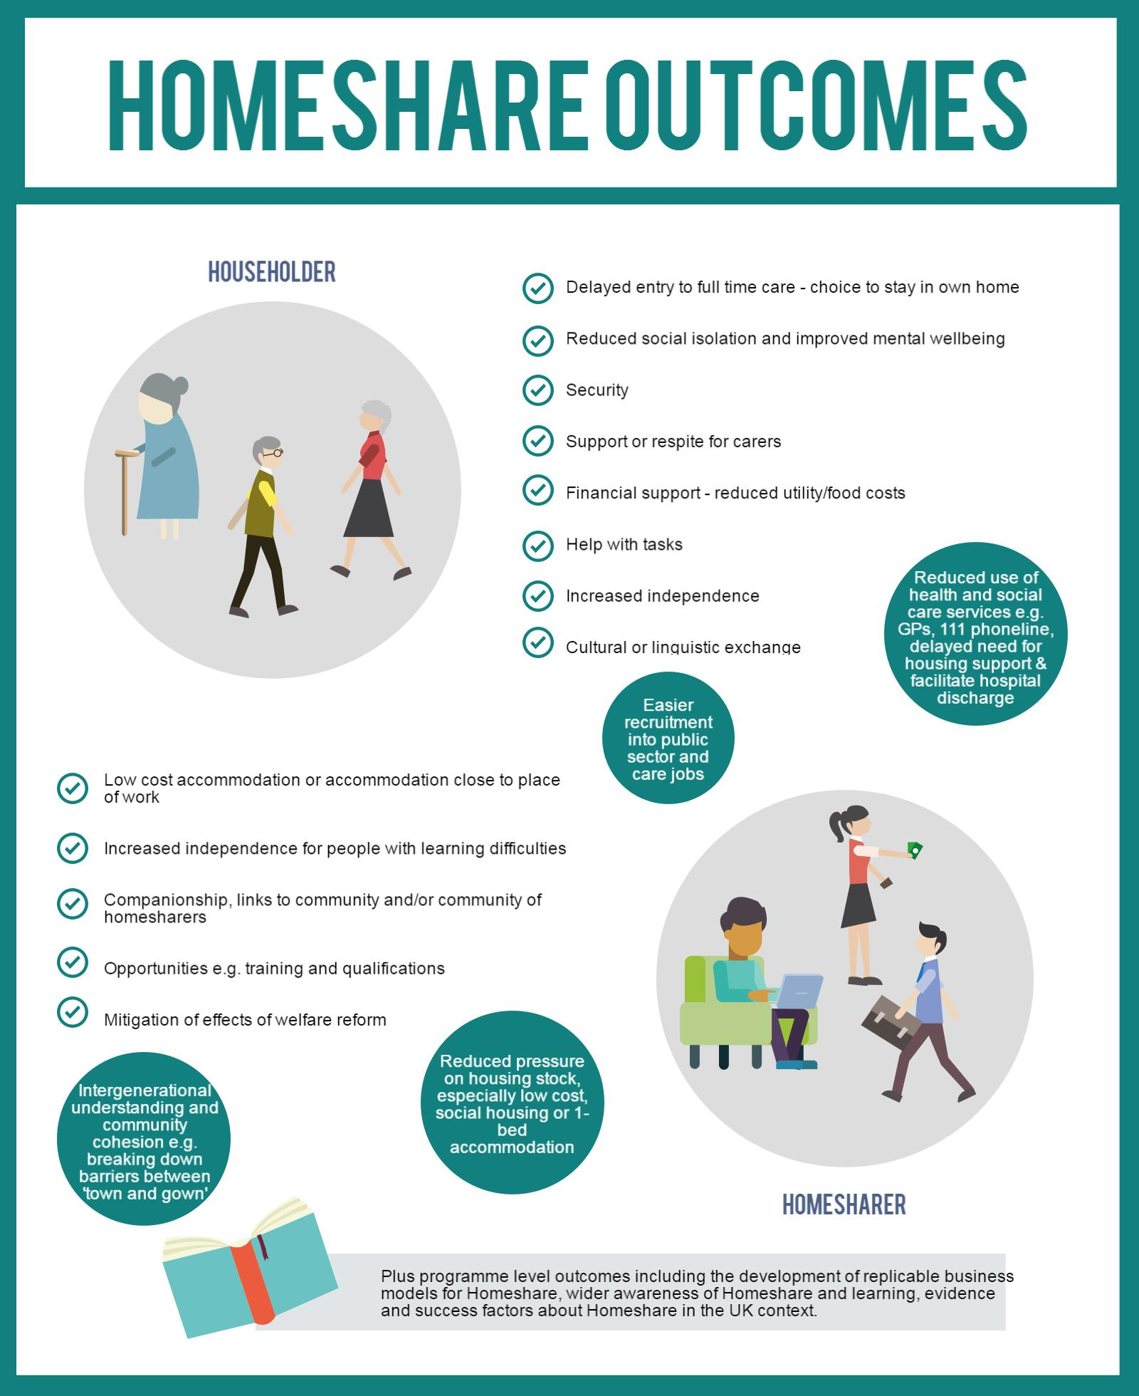
Summary of outcomes for householders and homesharers

Summary of HSP site level scoping
Summary of key findings from thematic analysis of site level scoping work

All sites share a set of common outcomes which are summarised and illustrated in an infographic (p.23) and which should enable to HSP to test comprehensively the core Homeshare model.

There is a wide range of additional local objectives and priorities which will enable the HSP to also test a variety of extensions and innovations to the core Homeshare model in different UK settings.

Pilot start-up has experienced some delays, including difficulties in recruitment but these have now all been resolved and all pilots are now launched.

Start-up activities such as marketing, matching processes, setting fees, developing the local Homeshare agreement and support arrangements are all now well in hand.
All sites are well engaged with the HSP evaluation approach and processes and are developing their own local evaluation plans.
Logic models to support business planning and evaluation have been co-produced and validated with all sites.
Key enablers identified so far are:
- Building on experience by drawing on past learning through Shared Lives Plus and others.
- Good communications which present the Homeshare concept clearly in plain language.
Segmenting to adopt different advertising and marketing strategies for different audiences.
- Using evidence so that activities and expenditure are informed by knowledge of what works.

- Being more business-like to streamline and systematise processes.

Barriers identified so far are:
- Anxieties of potential householders and homesharers about possible risks.
- Stereotyping in pre-existing attitudes to younger or older people.
- Homeshare as an unfamiliar concept and the need to attract people to a new idea.
- Uncertain demand which affects planning for targeting potential participants.

Insights from HSP strategic partners

In this chapter we summarise the key findings from our scoping interviews with the strategic partners.

Impact of the partnership on HSP outcomes
As part of this process evaluation it will be critical to understand the role that the partnership itself will play in the success or otherwise of the programme, and the relative value of the contributions made by the partnership structures, pilot site selection processes, monitoring, evaluation and support arrangements and the national support offer, including elements such as the financial modelling tool, business mentoring and the website and information sharing “hub” as these come on stream. These elements will also need to be considered as possible key factors in what makes a successful Homeshare scheme for future investment. For this reason interviews with individuals from each of the partnership organisations were a key strand of the scoping work and explored:
- Partner roles and motivations;
- Learning from site commissioning and selection;
- Partnership working;
- Learning from programme start-up; and
- Priorities for further learning and outcomes.
The scoping discussions have also contributed to the development of the programme level logic model provided at Appendix B and described further later in this chapter.

Partner roles and motivations

Partnership roles
The respondents described their understanding of the roles of their organisations in the HSP programme:
- Lloyds Bank Foundation initiated the HSP and brought the other partners on board. They were interested in the Homeshare model but were aware that existing models were not operating in a sustainable way. They were also responsible for selecting two of the pilot sites and managing the grant process for those sites. Their role is also to provide direct support through a mentoring scheme and a financial modelling tool to support pilot Homeshare projects towards sustainable futures.
- Shared Lives Plus is leading in developing the partnership network for the programme and in communicating with the pilot sites and feedback to the partnership. They will be providing technical and sub-sector support to the pilot sites.
- Age UK is to oversee the overall coordination and programme management of the HSP. They have been involved in organising the Partnership Board and Delivery Group. They conducted initial research on Homeshare models in the UK and across Europe. Age UK are also responsible for ensuring that the interests and voices of homeowners are understood and taken into consideration across the pilot sites.
- Foyer Federation’s relationship with the network of housing associations and understanding of the housing market is one of the key reasons they have been brought on board. They are also responsible for ensuring that the interests and voices of homesharers are understood and taken into consideration across the pilot sites.
- Big Lottery is jointly leading the partnership as one of the two core funders of the programme. They are responsible for selecting six of the eight pilot sites managing and monitoring the delivery and grant processes with their funded sites.

Partner motivations
Partners were motivated to get involved with the HSP for a wide range of reasons. These included:

Motivation | Comment
Supporting Homeshare projects as part of a wider Partnership group. | “[We wanted] to test whether a national programme approach with multiple partners offering a range of expertise to the pilot sites can be successful in helping develop viable and sustainable Homeshare projects.” (LBF)
Developing new ways of working. | “It was an opportunity for us to work in a slightly different way. In this partnership – we are leading a lot, which is different to the other programmes we fund. While our overall strategy at Big Lottery is to not lead, this experience provides us with an opportunity for a lot of learning about taking on this role in this way.” (Big Lottery)
Supporting a network of Homeshare pilots. | Rather than supporting projects in isolation we wanted to assess what impact having a network of pilot sites as well as partner expertise and contacts had on the success of the pilot sites. (LBF)
Developing learning on the Homeshare concept in a UK context, due to the lack of UK evidence. | “It has been successful on the continent but not gained traction here so we were interested in taking part. But our interests are broader, we are keen that within our own network we reflect what is working and what is not from this programme – so to offer a view and expertise to contacts and organisations about what has worked well and what hasn't.” (Age UK)
Explore the potential for a financially sustainable Homeshare model. | The objective of the partnership is to explore the potential for sustainable and effective models and funding streams and support those organisations as a partnership.” (Shared Lives Plus)
Understand the scope for rolling out the model more widely across the UK. | “We want to identify the success factors and potential for upscaling.” (Shared Lives Plus)
Addressing the needs of service users. | “This is one possible way to address the needs of elderly people we work with. The intergeneration aspect was of interest to us as well, it addresses the needs of both young people and elderly.” (Age UK)
Generating alternative funding models in a climate of public funding cuts. | “The Foyer model is becoming unsustainable in context of cuts for Local Authorities. We felt that Homeshare might offer a route into low cost housing for young people and might form part of an alternative to our offer.” (Foyer Federation)

Commissioning and site selection

Criteria for selecting sites
The HSP partnership set a number of key criteria for selecting the final mix of pilot sites which included:
- A good spread of pilot sites across the UK – wide geographical coverage;
- A range of organisations (including Local Authorities and charities);
- A range of different Homeshare models (e.g. rural areas, market towns and cities);
- Pilots that would broaden the appeal of the Homeshare concept;
- Pilot sites that could demonstrate they would identify opportunities for growth and address the challenges to growth within their Homeshare scheme;
- Pilot sites willing to share any learning generated from their project with the national programme;
- Pilot sites demonstrating a clear market for homesharers and homeowners (e.g. student populations);
- Proposals demonstrating beneficiary groups included those most in need;
- Pilot sites with existing relationships with partner organisations that would help them understand and target both homesharers and homeowners. In particular, they needed to demonstrate how they were able to access and understand the needs of elderly people in their locality. This included explaining how they would recruit and communicate with this group;
- Pilot sites with clear plans to make the project sustainable in the long term;
- Proposals showing how safeguarding issues would be handled; and
- Adding value to the local context rather than duplicating efforts.

What worked well during the commissioning process
LBF and Big Lottery were initially concerned that they might not receive a sufficient number of viable bids. However, LBF was able to choose sites based on research they had conducted and Big Lottery received 68 applications. The level of interest exceeded their expectations and they received bids from an interesting mix of organisations with diverse Homeshare models;
“It went really well – we were expecting about 15 applications and we got 68 – and such a broad range of applications which was really encouraging. It has meant we have ended up with six really broad organisations/ pilots – with a wide range of beneficiary groups and models.” (Big Lottery)
There were a number of other examples of success factors:
- Big Lottery held an open day for interested organisations to come along and find out more about the funding opportunity which proved a successful strategy in attracting organisations to apply;
- Working with partners to attract bids and choose pilot sites worked well. Shared Lives Plus helped attract bids, and both Shared Lives Plus and Age UK helped Big Lottery choose the successful sites.
- Big Lottery purposefully did not specify how much funding applicants could apply for. This worked well because it meant applicants had to demonstrate a financial model to support their case for funding and to show their plan to become financially sustainable in the long term;
- A broad specification in the tender had worked well for Big Lottery and contributed to the high number of applications they received. The number of applications demonstrated an appetite for Homeshare and Big Lottery considers they have potentially attracted organisations that wouldn’t have otherwise thought about Homeshare schemes and therefore have raised awareness of the model.

Challenges during the commissioning process
Working across different funders has been a challenge and has resulted in some delays. It has been difficult for all the partners that pilot sites were not chosen as quickly as had been anticipated. The delay has been frustrating and hampered momentum but has also had benefits. Partners acknowledged the need to not rush a process like this one:
“We’re very delayed – this has created some frustrations – we have had to put everything on hold and there has been a limit to how HSP can progress stuff… I recognise it’s not something you can rush at and it takes a gestation period.” (LBF)
Big Lottery considered that having more time to select pilot sites would have been beneficial. More time would have allowed them to visit each pilot site on the short list before make the final selection. They would also have liked more input from neutral professionals who understood the local context of each pilot site, as well as input from people delivering existing Homeshare schemes, in order to help them choose.

HSP partnership working
All interviewees felt that good relationships had been built among all the partners in the Partnership Board. It was felt that there was a strong desire to get things right from all parties involved and the partnership board had access to a wide range of expertise. Respondents felt that comfortable and open relationships had developed, that there had been very good collaboration, with genuine sharing, openness and honesty.
There was recognition that there is still some progress to be made in all the different partner organisations finding a common language.
“We don’t always talk in the same language yet - some are practice orientated and some are task orientated so it is about finding the right balance between us all.” (HSP partner)
Some partners felt that the Partnership Board had taken too long to clarify each partner’s role and remit. Some respondents felt that this may have been because of the delay in choosing all the pilot sites and the Board therefore having too much time to dwell on this issue. Establishing leadership responsibilities for driving the overall work forward contributed to delay in clarifying other roles. Most felt certain that once pilot sites were up and running it would be easier to assess the remit of each organisation’s role.
Because a number of the partners need to communicate directly with pilot sites, there is a need to manage sensitively the lines of communication. Ensuring that pilot sites are not overburdened and that all messages are consistent is important.
- Some challenges had emerged due to having two very distinct funding organisations working together. The commissioning process was a good example. For example, as a public funded body, Big Lottery had more rules and guidelines to follow, which meant it took them longer to go through the process.
- A formal system for sharing learning emerging from pilot sites had not yet been established. All respondents felt that going forward having this system would be very beneficial.
- Despite the delays the HSP has faced, there was an acknowledgement from all respondents that this was not something that could be rushed and that it would inevitably take a long gestation period.
- Going forward there was a consensus that there should be a clear focus on how the partnership organisations work together. This includes considering how the partnership can get the most out of the organisations round the table.

Learning from the start-up work

Establishing the pilot sites

Pilot sites have found it difficult to recruit for key posts. This has delayed the start of many of the pilot sites Homeshare projects. Several partners anticipate that gaining the trust of householders and persuading them to open up their houses to homesharers will be one of the biggest challenges and may result in longer lead-in times than originally envisaged.
Age UK emphasise the importance of pilot sites safeguarding against any possible risk of harm to elderly homeowners and to young people. Having early plans in place about how this will be managed is of vital importance.
Initially it was envisaged that Age UK would be the conduit of information to all the pilot sites so that each pilot site would have one main point of contact rather than several. It has become apparent however that the sites will need to have direct contact with several partners, as well as the independent evaluators. It will be very important therefore to manage those lines of communication, so not to over-burden pilot sites and avoid contradictory messages.

Wider programme level learning
Big Lottery commented that there are currently limited outcome measures for the programme as a whole. They saw this as a key area for further work and attention, in collaboration with LBF. They were keen to develop a shared system of how the partnership will be gathering and using learning from the pilot sites and how they will monitor outcomes.
Foyer Federation highlighted some of the significant challenges that the Partnership faced in terms of engaging a wider range of stakeholders in the national programme:
- Due to the delay in start-up for the majority of the pilot sites, it is hard to engage certain stakeholders without many “live” examples of a Homeshare pilot;
- Some potential stakeholders face contradictions between supporting Homeshare and their own missions and policy positions;
- The challenge for Housing Associations is around security of tenure. They are finding it challenging to persuade someone to leave secure accommodation with a six month shorthold tenancy to less secure accommodation, or to be able to offer alternatives should it no longer be viable.
- The welfare benefits system is also a key barrier which removes a significant cohort of housing association tenants because the monthly fee is ineligible for housing benefit so Homeshare is only viable for those on low wages not in receipt of housing benefit.

Priorities for further learning and outcomes
The partner organisations outlined some of the outcomes they most wished to see from the HSP. These include:

Outcomes for the programme
- To be able to assess (when all pilot sites use the financial modelling) what the optimal charging levels for certain number of matches;
- To assess what level of investment is required to make a Homeshare project a commercially sustainable operation;
- A substantive number of sustained matches across the pilot sites;
- To test whether the Homeshare model is a viable solution for addressing some of the following issues:
  - Providing a low cost option that would enable someone to relocate to London that otherwise would have not been able to afford to;
  - Addressing the issue of a lack of affordable housing for younger people;
  - Reducing social isolation and loneliness in older people; and
  - Allowing elderly people to live more independently.

Wider outcomes
- To broaden awareness of the Homeshare concept at UK level;
- Growth of the networks for partner organisations involved;
- Building new relationships between organisations in this sector; and
- Learning generated about partnership working in general.

Priorities for further learning from the evaluation
We asked the partner organisations what they wanted from monitoring and evaluation that takes place. The key themes that emerged are outlined below:

Harmonising reporting requirements
At the point of interview, both Big Lottery and Lloyds had their own monitoring system with significant differences between the requirements of both funders. There was general consensus among respondents that there would be a value in a consistent approach to collecting monitoring data in order to effectively compare and share lessons learnt across the sites, which has subsequently been addressed. Some respondents suggested having a shared monitoring tool that would satisfy the needs of both funders and this has now been incorporated in the current reporting arrangements.
Ensure the evaluation fits in with the local context
A balance is needed between how information is collected from the pilot sites and the time and resources that pilot site staff have to collect that data. A tension might exist between what is being asked of pilot sites and what they are capable of collecting so the HSP must find that balance and deal with any tensions that might exist.
Partners considered it important that evaluation findings are shared at the local level in a way that pilot sites can use and is relevant for their context and needs. It would be useful to work with pilot sites in order to explore how they can use the data and analysis themselves locally with local stakeholders.
It is critical that the evaluation only asks for useful information that will feed into the strategic objectives of the HSP. It is therefore important to always understand why the pilot sites are being asked for any given information.
The evaluation should generate shared learning
A common message emerged from the interviews about the need for clarity on how the evaluation will feed into the partnership and how the evaluators will hold and share the learning they gather. It is also very important to partners that they have access to timely information in order to be able to capitalise together upon any lessons learnt.
Overall, respondents spoke about wanting the evaluation to generate in-depth insights into why Homeshare works well in some areas and not in others particularly the enablers and challenges. The evaluation should:

- Identify what makes the pilot sites financially successful and sustainable. It is important to examine the business models and identify whether there need to be changes made to enable them to be sustainable;
- Assess what needs to be part of the Homeshare agreement and assessment process and identify best practice across the different pilot sites;
- Ascertain who the typical householders and homesharers are so that the information can be used to target the most appropriate audiences and effectively promote the programme;
- Include research around the potential costs and benefits to the public purse of the HSP. It should estimate how much could be saved in social and health care costs. Putting a pound sign against some of the benefits to homesharers and homeowners would also be beneficial;
- Consider how effectively all the pilot sites are working together and sharing learning;
- Focus on which beneficiary groups these Homeshare projects have the most impact. Identifying for which groups Homeshare works best for and is most suitable for will be key information;
- Identify what kind of organisations these pilot sites want to be targeting and working with;
- Assess how the partnership works and identify how it can get the most out of the organisations round the table.

Programme level logic model
These insights have contributed to the production of a logic model for the programme, building on an early draft prepared by the Big Lottery, linking with and supported by the common outcomes generated by the pilot logic models and validated in co-production with the HSP Delivery Group. (Programme level logic model provided as Appendix B).

Summary of key insights from strategic partners

Summary of key insights from scoping work with HSP strategic partners

The lead-in work has taken longer than initially envisaged and has been affected by different internal requirements across the two funding partners.
The timeframe has been further delayed by unforeseen issues at pilot level including difficulties with staff recruitment and revisions to business plans.
Partnership roles and responsibilities have been clarified and developed and are now bedding down after a busy and challenging lead-in period for the programme.
Working relationships within the partnership are comfortable and open with good collaboration and genuine sharing, openness and honesty.
There is still progress to be made on finding a common language across the different organisations within the partnership group.
Harmonising the monitoring arrangements across the programme has been a priority for the partners and this has now been achieved.
Key enablers for commissioning and selection of pilot sites included:
- Using an open day to attract applicants;
- Working with partners to attract and select applicants;
- Using a broad specification which raised awareness and interest;
- Not specifying funding levels so that applicants had to develop their own financial case.
Key challenges during this phase included:
- The different internal requirements for the publicly funded and private sector funding partners for whom different accountability requirements apply;
- Low security of tenure provided by the Homeshare model which is a disincentive to housing association tenants in short term housing to take up this option;
- The welfare benefits system which excludes potential homesharers in receipt of housing benefit.
A programme level logic model has been developed which has built on an early draft by Big Lottery, linked to and informed by the common outcomes generated by pilot site logic models and validated in co-production with the Delivery Group.

Quantitative analysis

In this chapter, we summarise the work undertaken by Aleron so far on developing and launching a data collection tool and profiling the areas in which the pilots operate.

Data collection tool development and launch

Co-production of the tool
In order to facilitate comprehensive and standardised data collection for the quantitative evaluation of the Homeshare programme, Aleron developed an Excel-based data collection tool. This, together with the guidance for use, is provided as Appendix C to the report.
For this, we first identified a core set of data points that would form the basis of our quantitative analysis; these data points were selected using a number of methods:
- Revision of the 2010 Homeshare evaluation;
- Outlining planned and existing data collection within individual pilot sites; and
- Identifying pilot sites’ working practices, participant life-cycle models, and planned interaction points between the Homeshare pilot site and the participant.

Validating and trialling the tool
Following these discussions, we developed a preliminary list of data points for collection, which was tested with sites using a Data Collection Feasibility Questionnaire. We used this feedback to make a final selection for our core dataset, and subsequently went on to design a preliminary version of the data collection tool. The tool underwent a round of feedback at the February Evaluation Workshop, where sites were given the opportunity to discuss some of the practicalities of using this tool. After incorporating the collected feedback, we developed a final draft of the data collection tool. This is currently being trialled with sites, and will undergo a series of revisions at the end of Q1 (June 31st 2016).
We have provided sites with two documents for the pilot:
- Independent Evaluator_Data Collection Tool
- Independent Evaluator_Data Collection Tool_Guidelines

The Independent Evaluator_Data Collection Tool is an Excel-based tool that sites will use to collect data about their participants. The tool follows the life cycle of a participant in an easy-to-use way. It is designed to guide the person using it through the various stages of a participant’s life cycle, from initial enquiry, to match end, and on into any rematches.
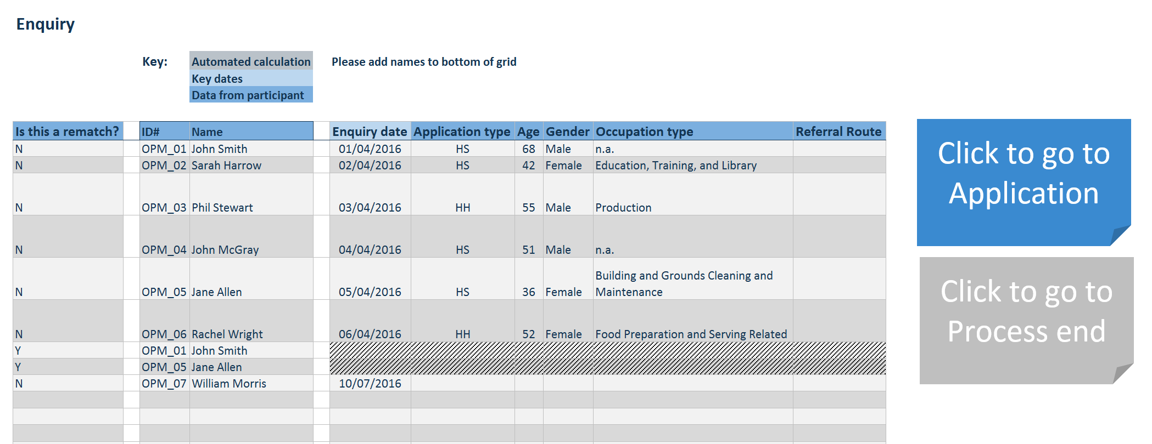
The Independent Evaluator_Data Collection Tool: the data shown in the image above is dummy data and does not represent any real participants.

The tool includes a ‘Site Dashboard’. The graphs in this section of the tool provide site-level information about the number of applications a site receives per quarter, the average length to make a match, by quarter, how many participants are being re-matched, among other information. This was added to the tool to ensure that sites are also gaining value from using it.
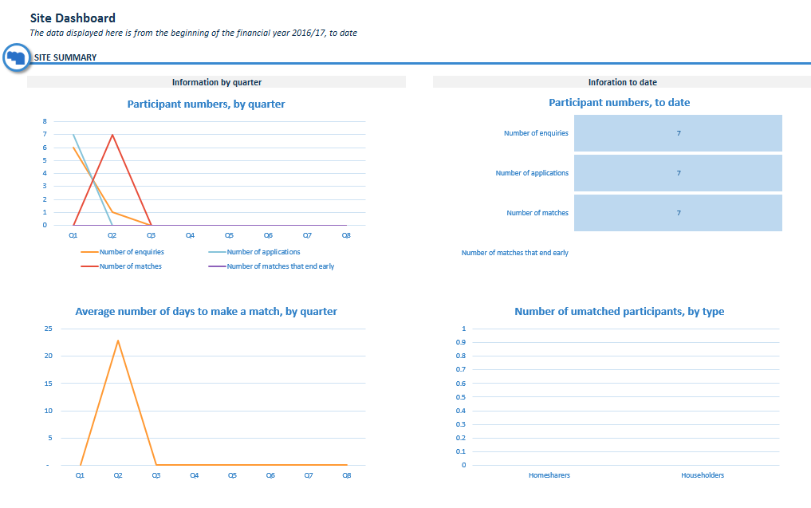
Site dashboard: the data shown in the image above is dummy data and does not represent any real participants.

We also provided sites with the Independent Evaluator_Data Collection Tool_Guidelines. This is a Word document (included as part of Appendix C) that guides site staff through using the data collection tool. The guidelines provide full explanations for each of the data points, RAG rating definitions, confidence statements and suggested collection methods.
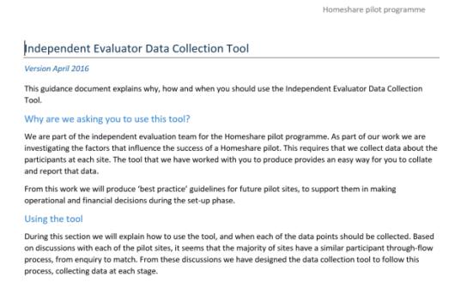
Independent Evaluator_Data Collection Tool_Guidelines

We have conducted embedding phone-calls with most of the sites, to ensure they are comfortable with using the tool, and are now in a period of ongoing support.

Area profiling
As part of the scoping work, Aleron undertook a secondary data analysis to create a detailed profile for the areas in which each of the Homeshare pilot sites are operating.
The area profiles are provided as Appendix D to this report.
Appendix E provides an overview of the rankings for seven of the sites drawing on the Index of Multiple Deprivation for England, with data for Edinburgh presented in a different format from the Scottish Index.

Key data points
Our methodology included a preliminary data design and scoping phase, to ensure that we had a set of consistent and comparable data points across each of the sites. During this phase we developed a comprehensive data indicator list - approved by the Homeshare delivery group - maximising use of available data and seeking to reflect key evaluative questions concerning Homeshare. We structured this list under three key headings:
- Demographics
- Household data
- Lifestyle data
To avoid undue complexity, we selected 14 core data points across the headings above. We suggest that these 14 data points represent a detailed snapshot of the key dynamics in each area.

Data sources
Below is a table containing the main secondary data sources used in the development of the area profiles.

Data type | Geographical regions covered | Data source
2011 census data | All | Office for National Statistics
Trend based Population Projection data | London boroughs | Greater London Authority, Strategic Housing Land Availability Assessment
Ward area data | Isle of Wight | Isle of Wight Council
Ward profiles | Oxford | Oxford City Council
Collection of datasets | Nottingham | Nottingham Insight
Bulk data files | Scotland | Scotland’s Census
2015 Annual survey of Hours and Earnings | All | Nomis, official labour market statistics

Data visualisation
In order to offer an engaging and easily comparable set of area profiles we selected three data visualisation techniques, which have been used for all areas.
- Bar charts to present percentage-based and numeric data;
- Pie charts to present proportion and percentage-based data;
- Colour coded maps to show within-area variations in a particular data points.
These area profiles are currently independent, descriptive datasets. Their value will be enhanced during the quantitative analysis phase of the evaluation, where they will provide a contextual background to analyses.

Planned use of the secondary data
Ultimately we will analyse the participant data against the profiling data collected here. We will use a weighted averages technique to identify which factors may be contributing to the success of a pilot. This will involve asking questions such as: are pilot sites in affluent areas more likely to see greater improvements in wellbeing outcomes? Are pilot sites in areas with high rates of long-term illness more likely to have longer average matches?
It is important to note that the eventual outputs of these analyses will be highly dependent on the sample size we receive from the pilots sites (i.e. the number of participants and/or the number of matches at a site). Although we can conduct the analyses with a small sample size, the smaller the sample, the harder it becomes to detect a significant effect.

Proposals for the next phase of evaluation

In this chapter we summarise our approach to the next phase of the evaluation, outlining the major strands of work, including primary data research with the pilot sites, provide milestone dates for key activities and highlight potential risks and mitigation approaches.

Formative changes to primary data collection method
Because of the longer lead-in timetable than originally envisaged we propose to adapt our primary data collection approach as described in the Introduction to this report and discussed further below.

Moving from standard timepoints to individual timepoints
We originally envisaged collecting a programme level baseline data set from site based fieldwork with all pilots early in the programme with this repeated towards the end of the programme to provide endline data which would enable measurement of impact. Qualitative work with householders and homesharers will provide core primary data for both baseline and endline but is dependent on a number of matches having been achieved at each site.
As pilots have started up both later than envisaged and with a wider range of launch dates, we therefore now propose to collect baseline and endline data to fit with the individual timetables and key milestones of each pilot. This means that we now plan to visit sites to undertake the baseline fieldwork between July and early October 2016 when a number of matches should have been completed and established at all sites and will report on the findings from this phase of fieldwork in November 2016.
Appendix F provides the revised timeline through to July 2017.

Planned next steps
During the next phase of work we will take a co-production approach and will take account of feedback from both the pilot sites and the partners to the findings and proposals from this scoping stage.
The six major strands of work for this phase are:
- Completing the comparative study feasibility: drawing on the data profiling undertaken to date we will outline options for an additional comparative evaluation; comment on how far further comparative study with other non-HSP Homeshare schemes could be practicable and useful and to advise the Partnership on the feasibility and likely costs of such a study. This will be submitted in a short paper at the end of May.
- Developing the detailed methodology for the site visits to collect primary data – for example, agreeing with sites the mix of methods that might be most locally appropriate, such as one-to-one interviews, focus groups, or participation in community circles (EDG). As part of this strand we will develop the data collection tools (interview/discussion topic guides) and analysis framework for co-production input from the Delivery Group.
- Developing the economic assessment framework drawing on the logic models completed for each pilot site, for co-production input from the Delivery Group.
- Reviewing the first quarter’s trial of the householder/homesharer journey data collection tool in June – we will analyse the data and make any final adjustments to the tool based on pilot feedback.
- Undertake site visits and conduct primary research with staff, homesharers, householders and other local stakeholders from July through to early October.
- Share emerging learning at an evaluation workshop with the pilots at the Homeshare stream of the Shared Lives Plus conference in early November.
These strands of work will feed into our interim report including baseline data which we will submit in late November.

Key activities and milestones for next phase of work
These key activities are summarised together with delivery milestones in the table below.

Activity | Complete by
Completing feasibility work for comparator study | May 2016
Development of fieldwork research instruments | June 2016
Evaluation support and sharing learning with sites | Ongoing
Collection and analysis of Householder/Homesharer journey data – review first quarter trial | June 2016
Analysis of monitoring and evaluation data | Ongoing
Economic assessment framework and approach | October 2016
Fieldwork with sites including primary data collection and analysis | October 2016
Review of pilot site logic models | October 2016
Evaluation workshop 2 – (Shared Lives Plus Conference 8/9 November) | November 2016
Interim report | November 2016

Managing evaluation risks and challenges
The evaluators review risk to the evaluation as part of the regular review of the risk register undertaken by the Delivery Group and new risks or changes in previously identified risk factors are also recorded in written updates completed every two months.

Risks and mitigations for the next phase of work
The table below identifies potential risks to the evaluation during the next phase of planned work and summarises the mitigating actions proposed.

Risk | Likelihood /Impact | Mitigation
Local data is inconsistent, incomplete or poor quality | L / M | A common tool has been developed to mitigate this risk. We will review first trial period in June and undertake joint problem-solving with pilots where problems.
Communications messages “overclaim” for HSP before evaluation is finalised | L / H | We will stay in touch with key communications timeline and have sight of any messaging linked to the evaluation.
Householders and homesharers reluctant to take part in primary research | M / H | We will encourage pilots to introduce the evaluation at application stage, and seek their help in accessing participants. We will provide clear written information for participants, and will be flexible on timings offering evenings and weekends where necessary.
Local professional stakeholders reluctant to take part in primary research. | L / M | We will ask pilots to provide introductions, offer long lead-in times and flexible interview timings, and offer phone as well as face to face interviews.

Concluding comments
Despite the unforeseen delays and difficulties in the early start-up phase of the HSP that have been discussed in this report, it has remained on track to meet its aims and objectives and there is already substantive formative learning to inform future work within the programme and to feed into the final outcomes of the evaluation.

We have taken account of the formative learning from the scoping stage to adjust the detailed evaluation design, methodology and timeline so that the evaluation will still be able to deliver on key formative and summative evaluation reporting milestones.

List of appendices

A – 8 x pilot site logic models

B – Programme logic model

C – Data collection tool and guidance

D – Area Profiling Data

E – Indices of deprivation data

F – Revised timeline

For more information about how Homeshare programmes operate, please see the Shared Lives guidance document: http://sharedlivesplus.org.uk/images/publications/01-SL-HOMESHARE-GUIDE.pdf
For more information about the Partnership, please see Homeshare UK press release: https://www.biglotteryfund.org.uk/global-content/press-releases/uk-wide/150615_uk_issues-for-young-and-old-alike
Information from scoping interview with PossAbilities.
This is based on the ratio between average city house prices and average gross local earnings. For more information about the Lloyds Bank Affordable Cities Review, see: http://www.lloydsbankinggroup.com/Media/Press-Releases/2016-press-releases/lloyds-bank/affordable-cities/
Information from scoping interview and Age UK Isle of Wight application document.
Information from scoping interview with Age UK Isle of Wight and Leeds City Council and application documents.
Information from Knowsley Housing Trust and PSS scoping interview and application document.
Weinstein, A. Market Segmentation: Using Demographics, Psychographics and Other Niche Marketing Techniques to Predict and Model Customer Behaviour (1993)
See Homeshare Practice Guide http://sharedlivesplus.org.uk/images/publications/01-SL-HOMESHARE-GUIDE.pdf
An Evaluation of Homeshare Pilot Programmes in West Sussex, Oxfordshire and Wiltshire, Oxford Brookes University, 2010
Some sites have yet to appoint a coordinator, or are in a period of flux; phone-calls will be held with these sites at a later date.

